 |  | TERMO DE ACEITE TÉCNICO
Solicitante: VIVO- Projeto Escolas Rurais
NOC/Operador: Rogerio Momi Frias |  |  | Cliente: VIVO
Empresa  EMC Brasil | VSAT-ID  VIVO-PER- |  | Link kbps  256/128 | Plataforma  VSAT
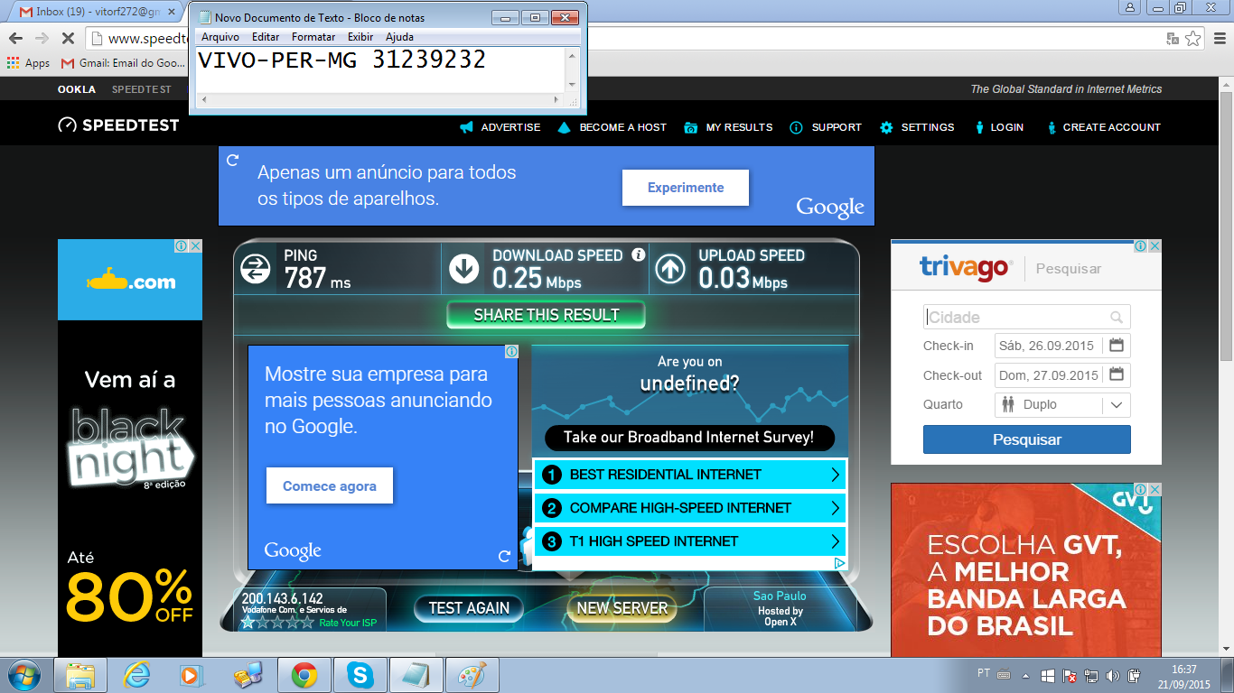

Satellite (DVB) RX Configuration
--------------------------------
Auto start : Enabled
Max MODCOD : 23 16APSK-9/10 (SNR threshold: 23.5 dB)
RX watchdog : 15 minute

Idx Pri SymbRate[Msps] Freq[GHz] Mode PopId Enable
* 0 0 9.320000 12.055825 DVB-S2 4 Yes
1 1 0.000000 0.000000 DVB-S2 2 No

Satellite (DVB) Receiver Status
--------------------------------
Rx State : On
DVB State : Forward link up
Network : 1326, GlobalIP@Telstar-14R
Frequency : 12.055621 GHz
Symbol Rate : 9.320062 Msps
S2 ModCod
- receiving : 13 8PSK-2/3
- current max : 23 16APSK-9/10
Pilot : On
Frame length : Short
DVB S2 Mode : ACM
Roll off : 0.25
SNR : 14.7 dB
Input Power : -28 dBm

Satellite (DVB) TX Configuration
--------------------------------
Auto start : Enabled
IDU Output Power : -30 dBm
IDU Max Output Power: 0.0 dBm
ODU Output Power : 34.7 dBm
EIRP : 48.0 dBW
Default CW Frequency: 0.000000 GHz
ATM mode : VC-Mux
Header Compression : None

Satellite (DVB) Transmitter Status
--------------------------------
State : On (TDMA)
IDU Output Power : -18.1 dBm
ODU Output Power : 34.9 dBm
EIRP : 48.2 dBW
Eb/No : 14.0 dB
Header Compression : Disabled
Timing correction : -187 us (261008 us)
Frequency correction: -260 Hz

Pinging 10.53.0.169 with 32 bytes of data:

Reply from 10.53.0.169: bytes=32 time=1870ms TTL=61
Reply from 10.53.0.169: bytes=32 time=1287ms TTL=61
Reply from 10.53.0.169: bytes=32 time=928ms TTL=61
Reply from 10.53.0.169: bytes=32 time=846ms TTL=61

Ping statistics for 10.53.0.169:
Packets: Sent = 4, Received = 4, Lost = 0 (0% loss),
Approximate round trip times in milli-seconds:
Minimum = 846ms, Maximum = 1870ms, Average = 1232ms

Pinging 10.29.2.233 with 32 bytes of data:

Reply from 10.29.2.233: bytes=32 time=3426ms TTL=61
Reply from 10.29.2.233: bytes=32 time=1109ms TTL=61
Reply from 10.29.2.233: bytes=32 time=918ms TTL=61
Reply from 10.29.2.233: bytes=32 time=844ms TTL=61

Ping statistics for 10.29.2.233:
Packets: Sent = 4, Received = 4, Lost = 0 (0% loss),
Approximate round trip times in milli-seconds:
Minimum = 844ms, Maximum = 3426ms, Average = 1574ms

ping 8.8.8.8
64 bytes from 8.8.8.8: time=1710 ms
64 bytes from 8.8.8.8: time=700 ms
64 bytes from 8.8.8.8: time=930 ms
64 bytes from 8.8.8.8: time=1610 ms
64 bytes from 8.8.8.8: time=1660 ms

--- 8.8.8.8 ping statistics ---
5 packets transmitted, 5 received, 0.00 percent packet loss
rtt min/avg/max = 700/1320/1710 ms

